Project Design Phase-II
Technology Stack (Architecture & Stack)
Date | 27 September 2026
Team ID | 6ab1d5c192b876d9664095f0
Project Name | Streamlining IT Procurement: Automating Standard Laptop Orders with Flow Designer
Maximum Marks | 4 Marks

Technical Architecture:
The Deliverable includes the architectural diagram placed directly below at the very top of the section, followed by Table-1 & Table-2:
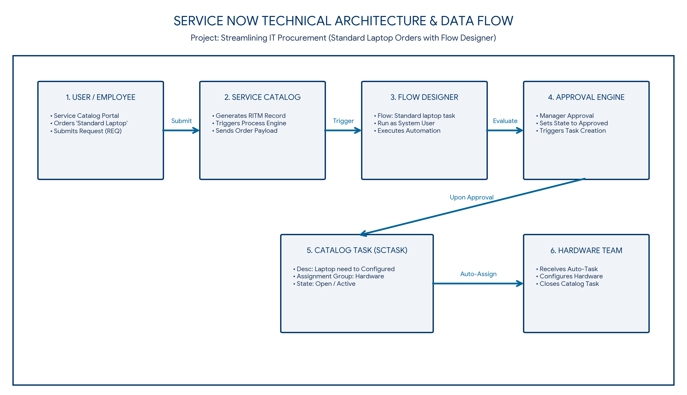
Figure 1: Technical Architecture & Data Flow of ServiceNow Standard Laptop Procurement Automation System
Table-1 : Components & Technologies:
Component | Description | Technology
User Interface | Self-service web portal for ordering standard laptops | ServiceNow Service Catalog / Service Portal (HTML, CSS, JavaScript)
Application Logic-1 | Automated workflow execution & Catalog Task creation | ServiceNow Flow Designer Engine
Application Logic-2 | Server-side business logic and record processing | GlideRecord API & JavaScript Engine
Application Logic-3 | Approval routing & multi-stage workflow engine | ServiceNow Approval Engine
Database | Relational database storing RITM, SCTASK, & CMDB asset records | MySQL / MariaDB (ServiceNow Cloud Managed)
Cloud Database | Enterprise cloud data store for IT Service Management | ServiceNow High-Availability Cloud Database
File Storage | Storage for catalog attachments & workflow audit logs | ServiceNow SaaS Cloud File System / Database Storage
External API-1 | Integration for automated email notifications & alerts | ServiceNow Email Engine / REST API
External API-2 | Data interchange format for catalog items & task attributes | GlideXML / GlideJSON REST APIs
Infrastructure (Server / Cloud) | Cloud deployment for high availability & global access | ServiceNow Multi-Instance SaaS Cloud Architecture
Table-2: Application Characteristics:
Characteristics | Description | Technology
Open-Source Frameworks | Standard web technologies utilized in Service Portal customization | JavaScript, HTML5, CSS3, AngularJS
Security Implementations | Role-Based Access Control (RBAC), TLS 1.3 encryption, and OAuth 2.0 authentication | ServiceNow IAM, OAuth 2.0, SSL/TLS, AES-256 Encryption
Scalable Architecture | Multi-tier SaaS cloud architecture supporting seamless enterprise scaling | ServiceNow Cloud Scale-Out Cluster Architecture
Availability | High availability setup with multi-datacenter redundancy & automated failover | ServiceNow Advanced High Availability (AHA) Data Centers
Performance | Sub-second workflow execution and cached catalog rendering | ServiceNow Flow Designer Engine & Glide Cache Optimization

